|  |  |  |  |
| --- | --- | --- | --- |
| **Qualification Details** | | | |
| **Training Package Code & Title** | **Electrotechnology Training Package (UEE ver 2.0)** | | |
|  | **UEE40720 – Certificate IV in Electronics and**  **Communications** | **State code:** | **BFP4** |
| **UEE40120 – Certificate IV in**  **Computer Systems** | **BFL8** |
| **UEE50520 – Diploma of Electronics and**  **Communications Engineering** | **BFL8** |
| **UEE50120 – Diploma of**  **Computer Systems Engineering** | **BFQ6** |

|  |  |  |  |
| --- | --- | --- | --- |
| **Student Name** | Richard Pountney | | |
| **Student Declaration** | I declare that the evidence submitted is my own work:  **~~RBP~~**  **………………………………………………………………………….** | | |
| **Assessors Name** | Saranya Chandrukannan | | |
| **Date Due** | Week 3 - 10 | **Date Received** | Click here to enter a date. |

|  |  |  |  |
| --- | --- | --- | --- |
| **Units of Competency (UoC) detailed in this DAP | Week/Stage/Block** | | | |
| **Unit National code and title** | *UEECS0018**Develop web pages for engineering applications* | **State Code** | **OCC10** |
| **Assessment Tool** | **Practical Assessment 1**  Develop simple and challenging program | | |

|  |  |  |  |  |  |  |
| --- | --- | --- | --- | --- | --- | --- |
| **Assessment Decision** | Satisfactory | | | Not Yet Satisfactory | | |
| **Assessor Signature** |  | | **Date** | | Click here to enter a date. | |
| **Feedback to student** | | | | | | |
|  | | | | | | |
| **Feedback from student** | | | | | | |
|  | | | | | | |
| **Student signature** | |  | **Date** | | |  |

|  |
| --- |
| **Assessment process instructions to Student and Assessor, including reasonable adjustment in the assessment process:** |
| As the student you are required to:   1. Students must successfully be observed and complete all the tasks and fill the “Debugging Table” at the end of the sheet 2. Students need to source all tools, equipment, technical information required. 3. Students are to talk to their lecturer if they have any questions related to completing these tasks. 4. The practical task is NOT completed until a final inspection is completed by the lecturer to ensure the work is to industry standards. 5. Students are to plan own work requirements and prioritise their actions to achieve the required outcome and ensure the tasks are completed within workplace timeframes. 6. Students must leave the work area clean and return all equipment to the store or as directed at the end of the practical tasks. 7. If you are deemed Unsatisfactory you will be given a second attempt. The student is to discuss with the lecturer on a date and time. 8. Adjustments to assessments may be made for you, providing the adjustments comply with set principles of assessment and rules of evidence If you require support for literacy and numeracy issues; support for hearing, sight or mobility issues; change to assessment times/venues; use of special or adaptive technology; considerations relating to age, gender & cultural beliefs; format of assessment materials; or presence of a scribe you need to inform your lecturer. Necessary adjustments can be discussed with the trainer prior to the commencement of the course. Refer to college intranet for Policy and Legislation: <http://intranet.smtafe.wa.edu.au/org/cs/services/Pages/policy.aspx> |

**Assessment Instruction**

**Instruction to the student:**

* OHS will be observed for the entire Assessment.
* The attached checklist will be used to mark your assessment submission. Please read it carefully before start working on your assessments.
* You must finish all the tasks/activities.
* You must fill the “Debugging Table” (at the end of the assessment sheet) with your problems/issues that you have faced during the program development process. **This table cannot be left blank.**
* This worksheet is to be completed during the lecture/lab, if possible, and submitted as a **single zip file or zipped file** via the Blackboard submission button before the due date.
* You can use the following tools to develop your programs at home. However, you need to represent your work and how have you done it to your lecturer.
* Computers with IIS enabled, ODBC, html editor.
* HTML tutorial: www.htmldog.com/guides/htmlbeginner/
* CSS tutorial: www.htmldog.com/guides/css/beginner/
* JavaScript tutorial: www.htmldog.com/guides/javascript/beginner/
* XML Tutorial: www.w3schools.com/xml/default.asp
* PHP Tutorial: www.w3schools.com/php/default.asp

# **Introduction:**

*This assessment introduces you to understanding the use of HTML and develop simple HTML-based website. To deepen your understanding of HTLM, CSS, JS, XML, XSL, php you are required to attempt all tasks and activities.*

**Student Checklist:**

Students are required to complete all the below activities within one week (**PC1.4)**.

|  |  |
| --- | --- |
| Tasks (OHS will be observed for the entire Assessment) **[PC1.1/1.2/2.1]** | Completed to Industry Standard. You will be required to demonstrate knowledge of established OHS procedures and best practices (e.g. safe handling practices) |
| Finish All the given Tasks |  |
| Log for problems and use the table (**Debugging Table**) at the end of the assessment. | **[PC 3.1/ 3.2/ 3.3 PC 2.6]** |

**TASK 1**

Go to [www.w3schools.com](http://www.w3schools.com) or  <http://www.htmldog.com/guides/html/beginner/>

Work through the topics listed on the right and ensure that you can get each of the code examples working. Once completed the above attempt the following:

|  |  |  |  |  |
| --- | --- | --- | --- | --- |
| **Step** | **Design** | **Performance Criteria** | **Knowledge Evidence/ Required Knowledge** | **Comments** |
| 1 | Create a folder called Assessment1**.** | **PC1.3** | **Critical Aspects** |  |
| 2 | Create a new html page called **contacts.html** in the Assessment1 folder.  Use Notepad++ or the Sublime editor to create your structure | **PC1.5** | **A** |  |
| 3 | Insert the HTML5 Doctype  **Explanation:**  Your HTML declaration must contain DOCTYPE, Head and body tags. Inside head add utf and language markup | **PC1.3** | **A,C** |  |
| 4 | Insert a title (<title>Contacts List</title>) of **Contacts List**  **Explanation:**  Your HTML declaration must contain head tags with title of the page we are currently using. Follow instructions from your lecturer how your design should look like | **PC1.3**  **PC2.2** | **T4,C** |  |
| 5 | Insert a first level heading (<h1></h1>) of **My Contacts**  Insert a second level heading (<h2></h2>) of **My Transport**  Insert a third level heading (<h3></h3>) of **My Education**  **Explanation:**  Your body declaration must contain h1 , h2 and h3 respectively.  Follow instructions from your lecturer how your design should look like  **If you have correct CSS markup browser will read h1, h2 and h3 correctly** | **PC1.3**  **PC2.2** | **T4,C** |  |
| 6 | Insert 3 paragraphs (<p></p>)  First paragraph must be between h1 and h2  Paragraph 1 should contain your full name, nationality and email address.  Second paragraph must be between h2 and h3  Paragraph 2 should contain description of your travels to TAFE  Third paragraph should contain your highest level of education obtained so far  **Explanation:**  Your body declaration must contain paragraphs which will fit inside h1 , h2 and h3 respectively. | **PC1.3**  The extent of development work is determined from page development specifications, including engineering subject matter, and in consultation with relevant persons.  **PC1.6**  **PC2.2** | **T4,C**  **T2,C** |  |

**TASK 2**

Once you have completed the above-mentioned tasks

* Validate the page using the Validator website <http://validator.w3.org/#validate_by_upload> **PC2.7**
* Save the validation response as a pdf in the same folder
* Correct any errors indicated and revalidate
* Keep all validation pages to demonstrate corrections made

Save the Validation pdf in Assessment1 folder.

**TASK 3**

|  |  |  |  |  |
| --- | --- | --- | --- | --- |
| **Step** | **Design** | **Performance Criteria** | KE /RS | **Comments** |
| 1 | Create a new html page called **index.html** in the Assessment1 folder.  We will connect these pages through add links so a user can navigate from one page to another | **PC1.3** | **T2** |  |
| 2 | Title: **Home Page**  **Explanation:** Our new index.html page must contain all head declarations and contain: Title: **“Home Page”** between title tags,  Utf declaration and links to CSS  Follow all instructions provided by lecturer in class how your pages should look like | **PC1.5** | **T2** |  |
| 3 | First level heading: **My Links in index.html**  **Explanation: Your h1 text should be: My Links**  Next step will ask you to add a paragraph with a link to contacts.html page we have created in previous Task1. | **PC1.3**  **PC2.3** | **T2** |  |
| 4 | In one paragraph insert a relative link with the text **My Contacts**. The link when clicked should open the My Contacts page created in Task1.  **Explanation:** When you run a home page in a browser and click on a link contact it will redirect us to a page contacts.html  **Give link** | **PC1.3**  **PC2.3** | **T2** |  |
| 5 | In index.html, In a second paragraph insert an absolute link to [www.google.com](http://www.google.com)  **Explanation:** When you run a home page in a browser and click on a link this it will redirect us to the Google search engine | **PC1.3**  **PC2.3** | **T2** |  |
| 6 | Now, Modify the page contacts.html in Task1.  We will add more elements in this page at next step | **PC1.3** | **T2** |  |
| 7 | In contacts.html, Change the email address to a **mail:to** link  **Explanation: You need to add a link to your email, so when a user click this link it will open an email to send.** | **PC2.3** | **T2** |  |
| 8 | In contacts.html, Add a table at the bottom with 5 columns and 2 rows as follows. Using CSS create and format your table to look like one below.  Use <th> for the cells in the first row and <td> for the cells in the second row. | **PC1.3**  **PC2.3** | **T2 CSS**  **RS1.2**  **RS1.4** |  |



**TASK 4**

Once you have completed the above-mentioned Task 3,

* Validate the page using the Validator website <http://validator.w3.org/#validate_by_upload> **PC2.7**
* Save the validation response as a pdf in the same folder
* Correct any errors indicated and revalidate
* Keep all validation pages to demonstrate corrections made

**TASK 5**

**JavaScript Quiz**

1. Inside which HTML element do we put the JavaScript?

<script></script>

1. Where is the correct place to insert a JavaScript body,head,title?

The correct place would be in the body.

1. How do you write "Hello World" in an alert box?

<div class="alert">

<span class="closebtn" onclick="this.parentElement.style.display='none';">&times;</span>

Hello World

</div>

1. How do you call a function named "myFunction"?

myfunction();

1. How can you add a comment in a JavaScript?

You add a comment by putting // for a single line comment & a multi-line comment you put /* & */ at the start & end lines.

1. Which operator is used to assign a value to a variable?

You use =

1. Is JavaScript case-sensitive?

Yes it is case-sensitive

1. **Fix the bug.**

function average(a, b) {

return a + b / 2;

}

console.log.average(2, 1);

1. Which of the following purpose, JavaScript is designed for ?

* To Execute Query Related to DB on Server
* To Style HTML Pages
* To Perform Server-Side Scripting Operation
* To add interactivity to HTML Pages.

1. JavaScript code is written inside file having extension.

.jvs

.js

.jsc

.javascript

**TASK 6**

**Using the files provided in the class follow next steps:**

|  |  |  |  |  |
| --- | --- | --- | --- | --- |
| STEP | DESIGN | Performance Criteria | KE/RS | Comments |
| 1 | Add all files on your local server XAMPP to run. Folder Architecture is important | **PC1.5;** | T2,T4 |  |
| 2 | Add 3 more book records to the XML file.  Use online bookstores to find three books relevant to engineering topics | **PC2.2;** | T3,t4,A,C,D |  |
| 3 | Modify the XSL file so that it sorts the books by publication date in descending order | **PC2,3;** | T3,T2,t4,C |  |
| 4 | Modify the XSL file so that it only outputs the books published by McGraw-Hill. | **PC1.6;**  **PC2.6 ;**  **PC 3.2;**  **PC3.3;** | T2,T4,T7,T8,C |  |
| 5 | Comment your code (including your student ID, First Name, and Last Name). Please write in the comment the purpose/objective of the code. | **PC 2.7**  **PC3.3** | T7,T8,C |  |

**TASK 7**

**Forms:**

**Activity 1 (PC1.5/1.6 PC2.2/2.3/2.4)**

Step 1. FORMS: Start Xampp server and create a Portfolio6 where all pages will be saved and run from.

Step 2. Your task is to create an application with forms.

* In the below screenshot we have provided you with xxxxxxxxx.php or xxxx instead the key/value pair.
* Replace it with correct page name and pass values to the second page.

**firstPage.php** given below

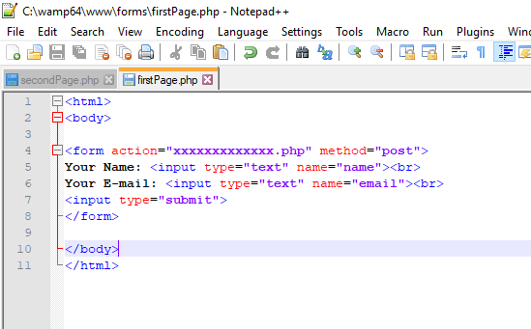

**secondPage.php** given below

Your second page contains [‘xxxx’]. In order to print (echo) a value in the secondpage we need to replace [‘xxxx’] with the attribute name.

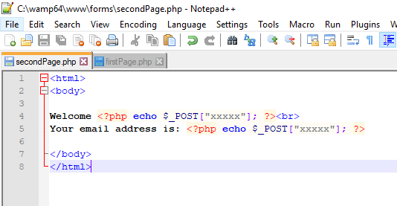

**Activity 2 (PC1.5/1.6 PC2.2/2.3/2.4)**

Step 1. FORMS: Start Xampp server and create a folder where all pages will be saved and run from.

Step 2. Your task is to create an application with forms.

* In the below screenshot we have provided you with xxxxxxxxx.php or xxxx instead the key/value pair.
* The same result could also be achieved using the HTTP GET method:

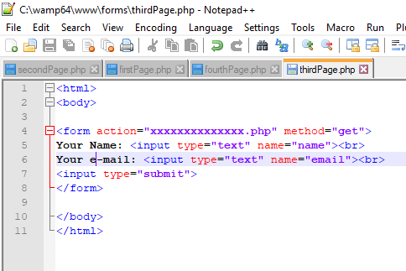

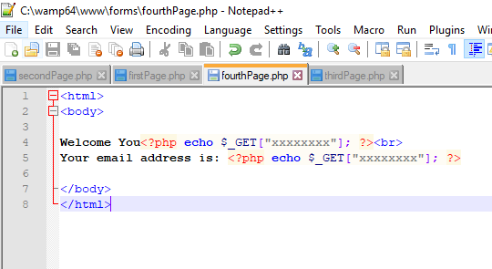

**Activity 3 (PC1.5/1.6 PC2.2/2.3/2.4)**

Here you need to create a ContactUs_form. When you create your Contact us page, this page should pass (POST) all values to the ContactUS_output. Your ContactUS_output should display all values which were posted.

**Your Contact Form Should look like this:**

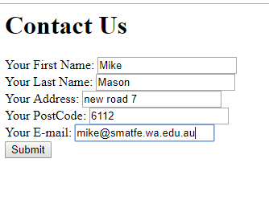

**Your Form outcome should look like this:**

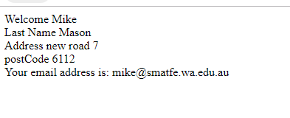

**Debugging Table (Must be filled)**

|  |  |  |
| --- | --- | --- |
| **Any problems, including errors and bugs** | **Solutions** | **Date** |
|  |  |  |
|  |  |  |
|  |  |  |
|  |  |  |
|  |  |  |
|  |  |  |

**Table 1**

**Complete All the above-mentioned Tasks and Submit through Blackboard**